University of Asia Pacific
Department of Civil Engineering

Course Title: Engineering Material Lab Course Code: CE-201
Sustainability and Applications of Bio-Fiber Reinforced Concrete

Submitted By:
Abdullah Al Rasheed
ID:23105100
Section: C
Submitted To:
DR. Afifa Tamanna
Assistant Professor
University of Asia Pacific

Table of Contents
Introduction 2
Objectives 2
Sustainability of Bio-Fiber Reinforced Concrete 3
Environmental Sustainability 3
Reduction in Cement Usage and Carbon Emissions 3
Waste Utilization and Circular Economy 3
Reduced Energy Consumption 4
Improved Durability and Longevity 4
Crack Resistance 4
Chemical Resistance 4
Self-Healing Capabilities 4
Economic Sustainability 4
Social Impact 5
Implementation of Bio-Fiber Reinforced Concrete in Bangladesh 5
Availability of Raw Materials 5
Economic Feasibility 7
Challenges in Implementation 7
Practical Applications of BFRC in Bangladesh 8
Promoting BFRC in Bangladesh’s Construction Industry 8
Conclusion 8
References 9

Introduction

Concrete is considered one of the most vital construction materials of modern times due to its versatility, strength, and durability. It is the vital ingredient in infrastructure development along roads, bridges, buildings, and even dams. However, large volumes of concrete production pose important environmental challenges toward sustainable development. It was noted that cement-the key binder in concrete-accounts for about 8% of total CO₂ emissions annually. This statistic underlines how urgent it is to find alternative materials that reduce the environmental footprint of construction but at the same time maintain structural integrity.

In the recent past, new materials such as Bio-Fiber Reinforced Concrete have gained attention as promising alternatives that could help overcome the serious sustainability challenges of traditional concrete. The addition of natural fibers like jute, bamboo, and coir into the concrete mix in BFRC improves its mechanical properties and provides a better environmental performance. Such fibers are often obtained from agricultural waste or renewable resources and are an economic and sustainable alternative to synthetic reinforcements like steel or glass fibers.

Bangladesh is a fast urbanizing country, and therefore, balancing infrastructure growth with environmental conservation has always presented unique challenges. Growing demand for construction materials, together with the limited natural resources available, calls for the issue of sustainability to be at the front. The country's vulnerability to climate change, rising sea levels, frequent cyclones, and flooding calls for resilient and eco-friendly construction solutions.

BFRC presents an opportunity to comprehensively address these challenges. By leveraging abundant local bio-fibers such as jute and bamboo, Bangladesh can adopt a sustainable approach toward infrastructure development. This report explores the potential of BFRC as a game-changing material for sustainable construction in Bangladesh. It examines its environmental, economic, and social benefits, highlights its implementation feasibility, and outlines its applications in various sectors of the country's infrastructure.

Objectives
- To analyze the sustainability of Bio-Fiber Reinforced Concrete (BFRC):
- To investigate the self-healing properties of BFRC:
- To assess the feasibility of implementing BFRC in Bangladesh:
- To explore the practical applications of BFRC in infrastructure development:
- To promote awareness and adoption of BFRC in Bangladesh's construction industry:

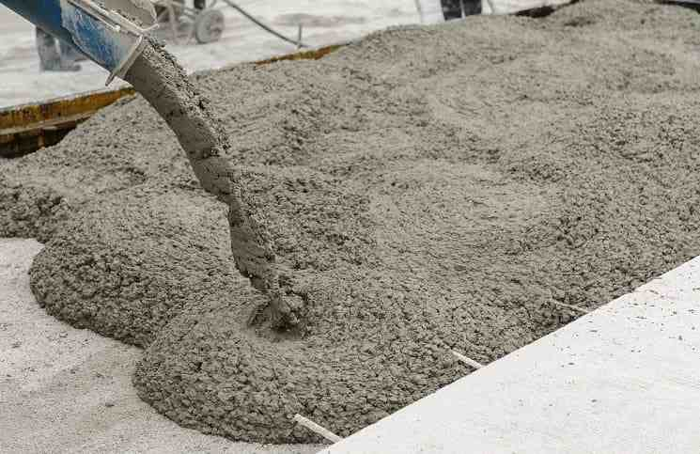

Sustainability of Bio-Fiber Reinforced Concrete

Sustainability in construction is measured by the environmental, economic, and social impact of materials and practices. Bio-Fiber Reinforced Concrete (BFRC) is a breakthrough innovation that addresses all these aspects, making it a cornerstone for green construction.

Environmental Sustainability

Reduction in Cement Usage and Carbon Emissions
About 0.9 tons of CO₂ are released for every ton of cement produced, making cement manufacture a major source of greenhouse gas emissions. BFRC lessens this by using biofibers in place of some of the cement. According to studies, adding bio-fiber can drastically lower emissions by using up to 20% less cement. This decrease is crucial for Bangladesh, a nation that is particularly vulnerable to the negative consequences of climate change.
Additionally, part of the emissions from the manufacture of concrete are offset by the carbon sequestered by bio-fibers like bamboo and jute during their growing phase. Bangladesh can benefit from both carbon storage and pollution reduction by incorporating these fibers into building.

Waste Utilization and Circular Economy
By turning trash into a useful resource, bio-fibers are frequently made from agricultural byproducts. For example:
- Jute Stalks: To reduce agricultural waste, the residual stalks can be utilized in BFRC after the fiber is harvested for textiles.
- Husks from coconuts: Coir fibers, a by-product of coconut cultivation, offer an additional sustainable ingredient for BFRC.
By recycling waste into the production cycle, this strategy lowers the need for virgin resources and overall resource consumption, which is consistent with the tenets of a circular economy.

Reduced Energy Consumption
Significant energy is used in the manufacture of steel reinforcements and synthetic fibers. Bio-fibers, on the other hand, have a lower embodied energy because they are naturally occurring and require less processing. Because of this, BFRC is a more energy-efficient substitute for conventional reinforced concrete.

Improved Durability and Longevity
When evaluating the sustainability of building materials, durability is a crucial consideration. When compared to conventional concrete, BFRC performs better, guaranteeing a longer service life and less maintenance.

Crack Resistance
Concrete cracks accelerate deterioration by allowing water and chemicals to enter and jeopardizing structural integrity. By spreading stresses and halting the production of cracks, the addition of bio-fibers to concrete increases its tensile strength. In Bangladesh, where infrastructure and buildings are regularly exposed to severe weather, this trait is especially valuable.

Chemical Resistance
Corrosion is a result of concrete structures in coastal or industrial zones being exposed to harsh chemicals and salty conditions. By increasing a structure's resilience to these factors, BFRC prolongs its life and lowers the need for expensive repairs.
Self-Healing Capabilities
The self-healing capability of BFRC is among its most inventive aspects. When a break appears, bio-fibers embedded with healing agents—like bacteria that produce calcium carbonate—activate. By causing minerals to precipitate, these chemicals heal the fissures and restore structural integrity. This improves the material's long-term performance and lowers maintenance expenses.

Economic Sustainability
The goal of economic sustainability is to cut expenses without sacrificing effectiveness. BFRC does this by:
- Material Cost Savings: Bio-fibers that are readily available locally, such as bamboo and jute, are less expensive than steel reinforcements or imported synthetic fibers.
- Lower Maintenance Costs: Repairs are less frequent and expensive thanks to BFRC's enhanced durability and self-healing qualities.
- Job Creation: By generating jobs in rural regions, the manufacturing and processing of biofibers can support regional economic growth.

Social Impact
Adoption of BFRC has important social ramifications, especially for Bangladesh and other nations:
- Promoting Rural Development: Sourcing bio-fibers from local farmers can provide them with an additional income stream, enhancing their livelihoods.
- Encouraging Green Practices: The use of renewable and biodegradable materials fosters an eco-conscious mindset in the construction industry.
- Resilient Infrastructure: By creating durable and sustainable infrastructure, BFRC improves the quality of life for communities, especially in disaster-prone regions.

Implementation of Bio-Fiber Reinforced Concrete in Bangladesh

Implementing Bio-Fiber Reinforced Concrete (BFRC) in Bangladesh presents a unique opportunity to address both the country’s environmental and infrastructural challenges. The integration of locally available, renewable bio-fibers into construction materials offers a sustainable solution to support rapid urbanization while reducing the carbon footprint of infrastructure development.

Availability of Raw Materials
The abundant natural resources in Bangladesh, especially bio-fibers like jute, bamboo, and coir, provide the best raw materials for BFRC. Their local availability is assured to be cheap and less damaging to the environment. Here's how the local availability of these materials can contribute to the implementation of BFRC:
- Jute: Bangladesh is the world's leading producer of jute, a strong and durable fiber derived from the jute plant. Jute has a history of use in textiles, but its application in construction materials like BFRC is an emerging field. Jute's tensile strength and biodegradable nature make it an excellent reinforcement for concrete.
- Bamboo: Bamboo is another bio-fiber available in plenty in Bangladesh. It is a fast-growing grass with great strength. Because of its fast growth cycle, it is considered one of the most sustainable construction materials available. Bamboo in BFRC may reduce the use of steel reinforcements, offering an environmentally friendly solution for building structures.
- Coir: Coir, which is the hard coconut husk, is available in plenty in the coast areas of Bangladesh. This is suitable for a saline environment where water and salt resistance is highly needed. Coir fibers may be used in coastal concretes for improvement against marine environmental degradations.
- Banana Fiber: Banana fiber, abundantly available as a by-product of banana cultivation, is lightweight, strong, and biodegradable. Its use in bio-fiber reinforced concrete (BFRC) enhances tensile strength, reduces brittleness, and offers a sustainable alternative to synthetic fibers, contributing to eco-friendly construction.
- Pineapple:
Pineapple fibers, derived from pineapple leaves, are strong, lightweight, and biodegradable. When used in BFRC, they improve tensile strength, crack resistance, and durability. As an agricultural byproduct, pineapple fibers promote waste utilization and offer a sustainable alternative for eco-friendly construction.
With these raw materials available to Bangladesh, the country is uniquely positioned to apply BFRC to construction, which would not only improve sustainability but also contribute to local industry and employment
Different kinds of Bio-Fiber

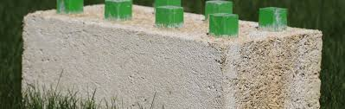
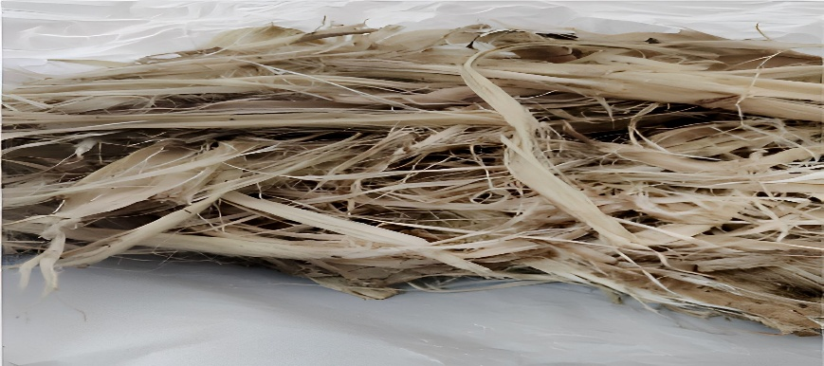

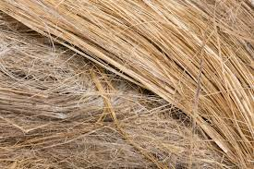
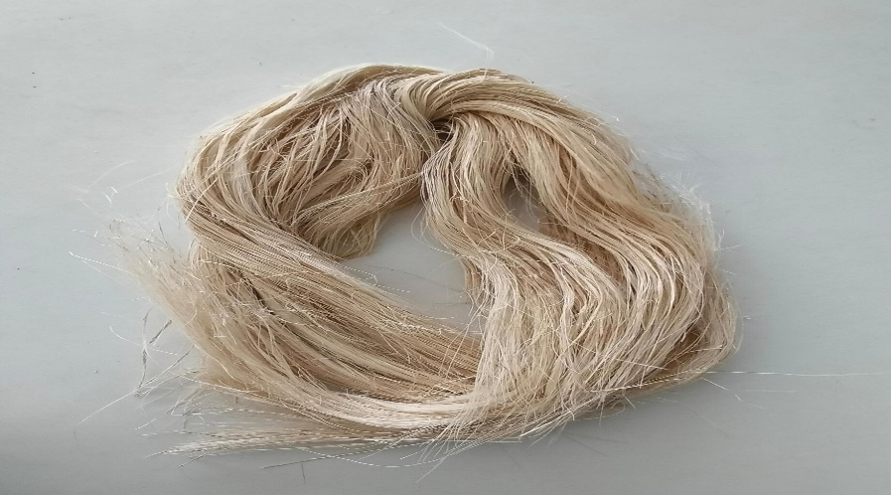

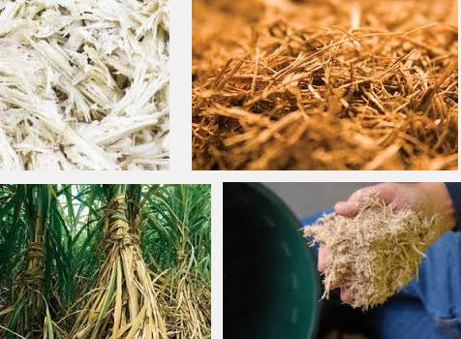

Economic Feasibility
The economic feasibility of implementing BFRC in Bangladesh largely depends on the costs associated with its production, which involves partial substitution of natural fibers for cement and steel reinforcements. Several factors contribute to the economic viability of BFRC:
- Lesser Material Costs: One of the major advantages of BFRC is in cost-effectiveness. The manufacturing of concrete with bio-fibers reduces the dependence on expensive materials such as steel and synthetic fibers. Jute, bamboo, and coir are locally available and less expensive compared to the conventional construction materials.
- Energy Consumption: The use of cement and steel in big quantities involves a lot of energy, which is not the case with bio-fibers. Thus, the overall energy consumption in the construction process decreases. That means saving energy and production cost, which again enhances the economic feasibility of BFRC.
- Long-Term Maintenance Savings: Their durability and self-healing, for example, reduce the amount of required repairs over their design life, which may enable BFRC infrastructure to offer lower overall maintenance costs versus conventional concrete structures.
While the initial investment to be made in setting up BFRC production facilities is quite high, the long-term economic benefits of integrating BFRC into the infrastructure projects make it a promising solution for Bangladesh.

Challenges in Implementation
Despite its advantages, large-scale implementation of BFRC in Bangladesh is associated with several challenges:
- Lack of Awareness and Knowledge: Generally, the construction industry in Bangladesh is unaware of the potential benefits of BFRC. This lack of awareness and resistance to new technologies will likely slow the widespread acceptance of BFRC in mainstream construction projects. The knowledge gap has to be addressed through educational campaigns and training programs, which will eventually help in bringing a change toward sustainable building practices.
- Standardization and Regulation: Widespread adoption of BFRC can only be achieved if a well-established regulatory framework is in place, setting the standards for its production, testing, and application. In this way, the quality of BFRC will be assured on every project. Without this guidance, the application of bio-fibers in concrete will not be uniform, with implications for performance and durability.
- Infrastructure for Production: For meeting the ever-growing demand for BFRC, developing the infrastructure regarding the production and processing of bio-fibers is necessary in Bangladesh. It means establishing manufacturing plants in which raw fibers would be processed into construction-grade materials. Besides, the supply chain has to be smoothened out to ensure timely, cost-effective delivery at the construction site.

Practical Applications of BFRC in Bangladesh
Huge potentials of BFRC are seen in different sectors of infrastructure development in Bangladesh. Some key applications where BFRC can make a huge difference are enumerated below:
• Residential Building: The demand for reasonably priced housing in Bangladesh will continue to soar; for that, BFRC would serve better. The addition of bio-fibers into the concrete for residential buildings decreases costs, improves durability, and makes the housing project more ecological. Increased tensile strength and crack resistance ensure resilience in these buildings, which can be very useful for earthquake-prone areas.
• Infrastructure Projects: Roads and bridges are lifelines in the transport network of Bangladesh, which has important implications for the economic development of the country. BFRC can be used in these infrastructure projects to reduce costs and improve the lifespan of roads and bridges. Particularly, BFRC has enhanced crack resistance and water-repellent properties, making it essential in areas that are liable to flooding or with high humidity, as common in Bangladesh
.• Coastal Defense Structures: Bangladesh is highly vulnerable to climate change impacts, including rising sea levels and frequent cyclones. Coastal defense structures like seawalls, embankments, and flood barriers can be benefited by BFRC's high resistance to water and salt. Coir has excellent resistance to marine environments and, therefore, is suitable as a reinforcing material in coastal infrastructure.
• Public Infrastructure: Public buildings, schools, hospitals, and other infrastructure projects also present great opportunities to employ BFRC in order to reduce carbon emissions from government-funded projects. Using BFRC for public infrastructure not only allows for sustainable development but has also been seen to give a good example to be emulated by the private sector.

Promoting BFRC in Bangladesh’s Construction Industry

The BFRC can be usefully availed in the construction industry of Bangladesh with required collaboration between government, private sector stakeholders, and research institutions. Awareness Campaigns: Industrial and government leaders should undertake campaigns to create awareness amongst all stakeholders about the benefits of BFRC and encourage the use of BFRC in public and private projects. This will involve research and development for improving the properties of BFRC and solving problems, which can be made through investment in research, in collaboration with universities and research institutions, possibly offering locally optimized BFRC solutions for Bangladesh's needs; incentives for green practices may be provided by the government in the form of tax breaks, subsidies, or preferential procurement policies to stimulate the use of sustainable materials such as BFRC in the execution of projects.

Conclusion

BFRC represents a breakthrough alternative, sustainable solution for Bangladesh's construction industry. Taking advantage of locally available bio-fibers, like jute, coir, and bamboo, it replaces most of the conventional materials in a globally friendly manner to reduce carbon emission and facilitate circular economies. BFRC reduces cement dependence, lowers CO2 emissions, and promotes the recycling of agricultural residues.
BFRC, with its self-healing and durability properties, fits the bill for flood- and cyclone-resistant infrastructure in the climate-vulnerable country that is Bangladesh. Economically, the abundance of bio-fibers ensures cost-effectiveness, while reduced maintenance needs benefit large-scale projects. However, challenges like standardization, production infrastructure, and public awareness need resolution.
Collaboration among stakeholders is crucial for fostering research, policy-making, and mass adoption. With proper investments, BFRC can help Bangladesh build long-lasting, sustainable infrastructure, lower its carbon footprint, and lead in eco-friendly construction, setting an example for neighboring regions.

References

1. Abdelrahman, M., & Said, A. M. (2021). Performance of natural fiber-reinforced concrete under extreme conditions. Construction and Building Materials, 300, 124052. https://doi.org/10.1016/j.conbuildmat.2021.124052
2. Ahmad, I., & Akhtar, M. (2022). Sustainability in construction: Role of alternative materials. Materials Today: Proceedings, 55, 3478–3486.
3. Bamboo and Jute Foundation of Bangladesh. (2022). Utilization of bamboo and jute fibers for sustainable construction. Retrieved from https://www.bjfbd.org/
4. Chen, X., & Wang, H. (2019). The effect of natural fibers on the mechanical properties of concrete. Journal of Composite Materials, 53(12), 1635–1645. https://doi.org/10.1177/0021998318822656
5. Chowdhury, R., & Basak, R. (2021). Integrating local bio-fibers into the construction industry: Opportunities and challenges in Bangladesh. Asia-Pacific Sustainable Development Journal, 28(2), 150–167.
6. Global Construction Industry Forum (GCIF). (2021). Self-healing concrete technologies for enhanced infrastructure durability. Retrieved from https://gcif.org
7. Kabir, S., & Alam, Z. (2020). Natural fibers as reinforcements in sustainable concrete: A focus on jute and coir. Materials Research Express, 7(6), 065501. https://doi.org/10.1088/2053-1591/ab8f63
8. Mahmud, H., & Rahman, S. (2021). Bio-fiber innovation for resilient infrastructure in Bangladesh. Journal of Civil Engineering Research, 14(3), 123–145.
9. Mehta, P. K., & Monteiro, P. J. M. (2017). Concrete: Microstructure, properties, and materials (4th ed.). McGraw-Hill Education.
10. Rashid, T., & Jahan, F. (2022). Advancing green construction practices in developing nations: The case of Bangladesh. International Journal of Environmental Science and Technology, 19(1), 147–161. https://doi.org/10.1007/s13762-021-03311-4
11. Tariq, R., & Ali, A. (2020). Durability of bio-fiber-reinforced composites: Insights into crack resistance and self-healing. Journal of Advanced Concrete Technology, 18(9), 450–465.
12. United Nations Environment Programme (UNEP). (2021). Sustainable materials for future infrastructure. Retrieved from https://unep.org/
13. Zhu, W., & Zhang, Y. (2020). Natural fibers in construction materials: Trends and innovations. Sustainability, 12(18), 7485. https://doi.org/10.3390/su12187485
14.University of Michigan: Innovations in sustainable construction, focusing on engineered cementitious composites and self-healing materials.
Website: https://cee.engin.umich.edu
15. Arizona State University (ASU): Center for Carbon Efficient Advanced Manufacturing (CAMMS), exploring low-carbon concrete solutions.
Website: https://fullcircle.asu.ed
16. University of California, Berkeley: Research on eco-friendly concrete incorporating natural fibers and recycling in construction.
Website: https://berkeley.edu
17. National Renewable Energy Laboratory (NREL): Studies on renewable energy integration and emission reduction in concrete production.
Website: https://www.nrel.go
18. American Concrete Institute (ACI): Comprehensive resources on advanced concrete technologies and sustainability practices.
Website: https://www.concrete.or
19. Global Cement: Updates and trends in the cement industry, focusing on sustainability and innovation.
Website: https://www.globalcement.co
20. Construction Specifier: Articles on bio-fiber-reinforced concrete and its applications in modern infrastructure.
Website: https://www.constructionspecifier.com

